Aristotle:

holoplastic pattern of cleavage (in which the entire egg is divided into smaller cells, as it is in frogs and mammals)

the meroblastic pattern of cleavage (as in chicks, wherein only part of the egg is destined to become the embryo, while the other portion-the yolk-serves as nutrition for the embryo).

Preformation: organ systems develop at different rates

Epigenesis: the embryonic parts of the chick develop from tissues that have no counterpart in the adult organism

Animal cap cells: Ectoderm-> surface layer of embryo, generate surface layer of skin and forms brain and nervous system

Marginal cells: Endoderm-> innermost layer of embryo produces epithelium of digestive tube and lungs

Vegetal cells: Mesoderm-> middle between ectoderm and endoderm. Blood heart kidney gonads bones muscles and connective tissues

Vegetal cells releases signals to form ectoderm and mesoderm and organizer.

Evolution is the process by which different species of living organisms have developed and changed over time, often through natural selection.

Theory of germ plasm -> distinction between somatic cells and germ cells

Mosaic embryos: cells in embryo are determined by autonomous specification with each cell receiving its instructions independently and without cell-cell interaction.

Regulative development: cells are able to regulate their behavior and interactions with neighboring cells in order to produce a functioning organism.

Grey crescent: create by cortical rotation

Paracrine receptor:

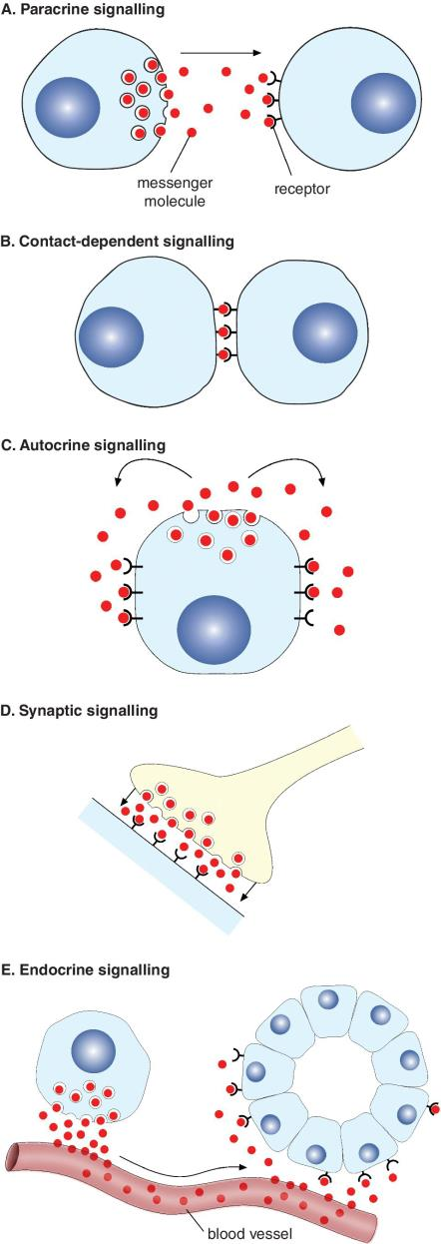

What is chimera: a DNA molecule composed of sequences from two or more different organisms or species.

Recent cell fate labelling techniques: in situ hybridization techniques; fluorescent protein-labelling and live imaging.